**ML Task Two Group Assignment (23 Marks – 5% of course work)**

**Instructions:**

1. Upload your group **Notebook** on your git account **deadline Wednesday 20th May** before Midnight
2. Some few useful links:

<https://towardsdatascience.com/handling-missing-values-with-pandas-b876bf6f008f>

<https://pandas.pydata.org/pandas-docs/stable/user_guide/missing_data.html>

**Question:**

Using the provided *House_Price_data*:

* 1. Prepare the data to form a matrix indicate how you dealt with: NaN Values (Note mere deletion attracts lesser marks), Infinite value errors **(5 marks)**

**Divided the dataset into numerical and object features based on type. Columns of type ‘int64’ and ‘float64’ were considered numerical. Columns of type ‘object’ were considered as object columns.**

**Used SimpleImputer to replace null values in numeric columns with the median value in each numerical column. Also used SimpleImputer to replace null values in object columns with a constant value, ‘’None””. This is because the null values in those columns represent absence of something which is valuable information.**

**After dealing with nulls, One Hot Encoded nominal features and Label Encoded ordinal features. Converted the now prepared data (excluding target) into a matrix.**

* 1. Perform **PCA** and filter out 2 **Principal Components (PC) (5 marks)**
  2. Determine the percentage of **information carried** by the above 2 Principal

Component **(1 mark)**

**PC1 – 7% and PC2 – 3%**

**iv.** If we were to capture **90% variance**, how many PCs will be needed? Provide code line **(1 mark)**

**108 PCs would be needed.**

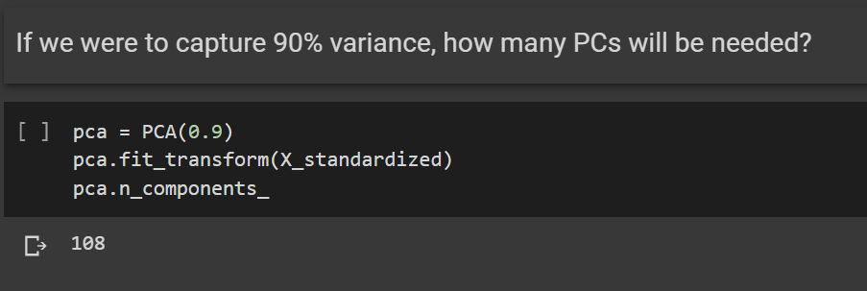

* 1. Plot a 3D plane of Best Fit **(10 marks)**
  2. Write down the **general linear regression equation** for this challenge using **only** two PCs **(1 mark)**

**y_hat = w1 X1 + w2 X2 + b**

**y_hat = 17073.5 X1 + 1120.12 X2 + 180921.2**